*Basic Commands*

1. Pwd :- (Present working directory) It gives us the absolute path.

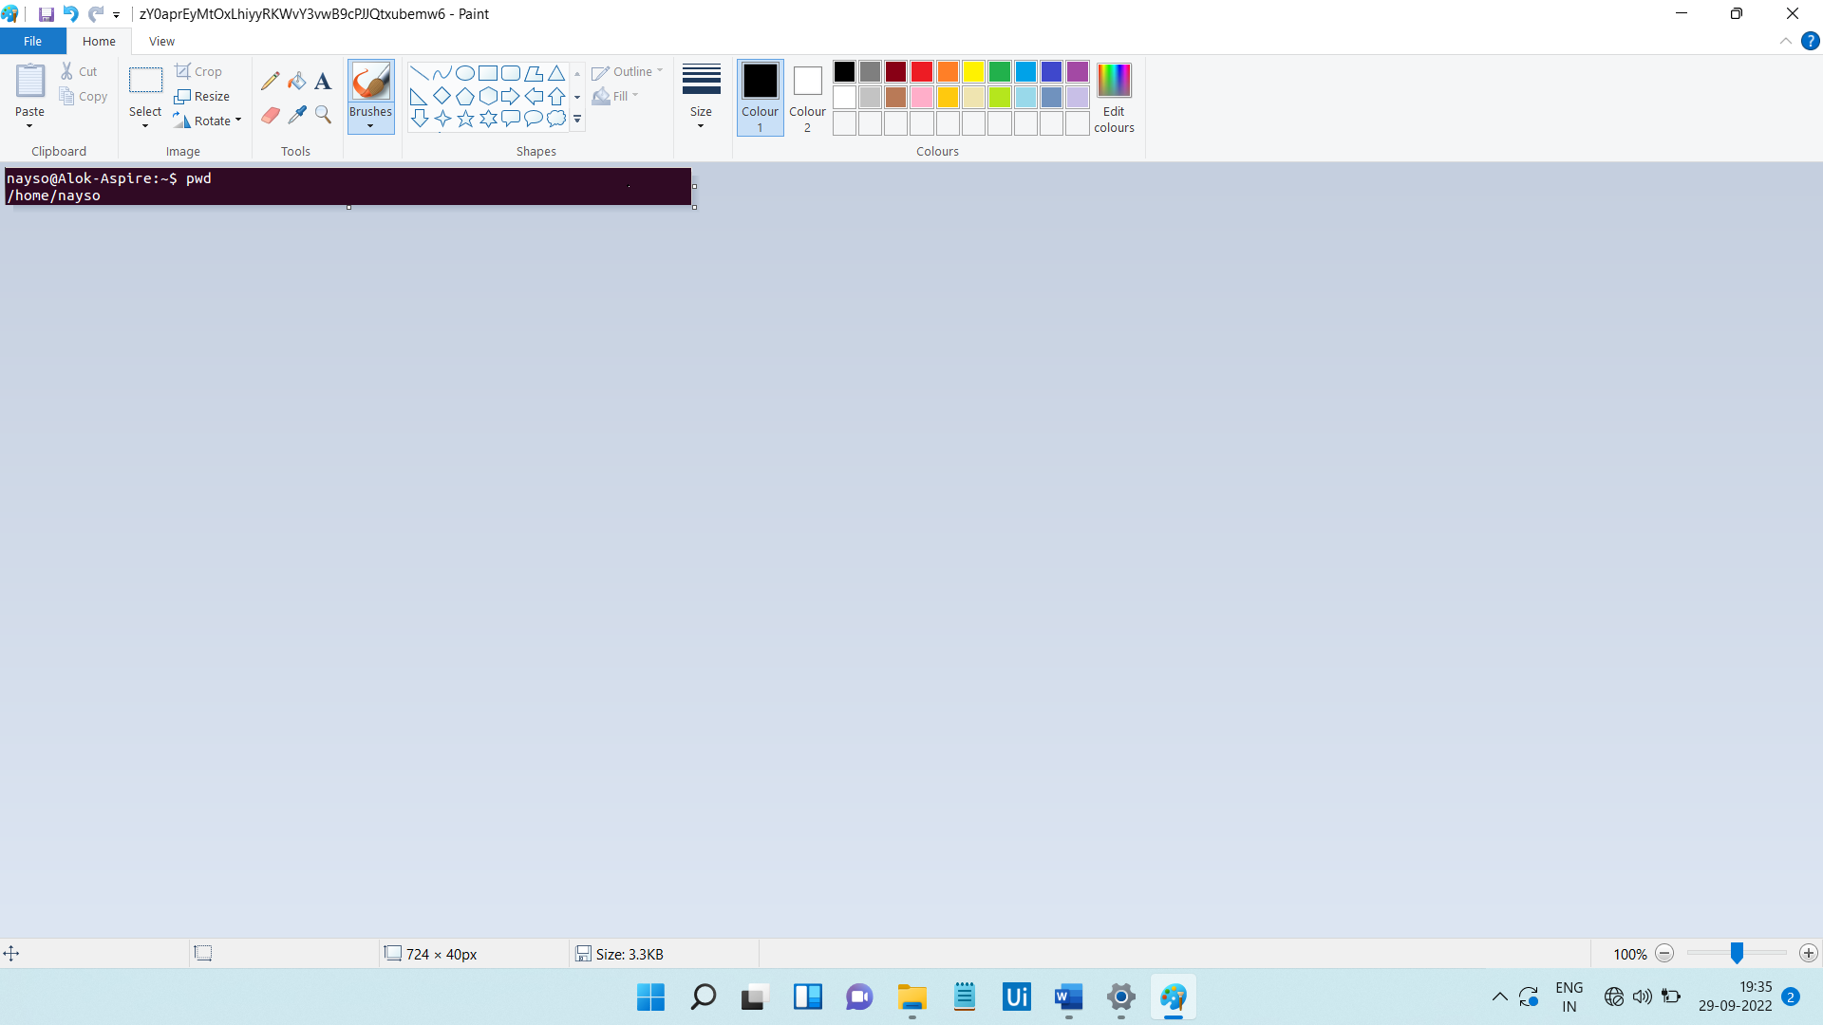

1. Ls:- This command is used to know what files are in the directory you are in.

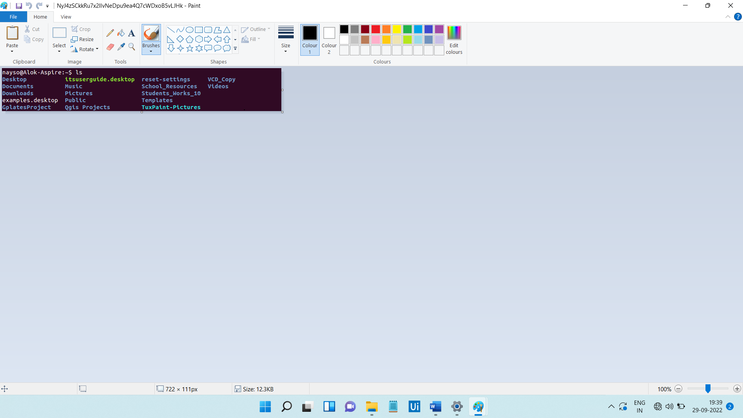

1. Cd:- Change directory is used to go to a directory.



1. mkdir:- This command is used to make a new directory under any directory.



1. rmdir:- This command is used to delete directory.



1. touch:- This command is used to create empty file.

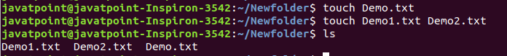

1. cat command:- It is used to create a file, display content of the file, copy the content of one file to another file, and more.

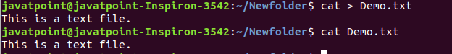

1. rm command:- This command is used to remove a file.



1. mv:- This command is used to move file or a directory from one location to another location.



1. cp:- this command is used to copy a file or directory.



1. rename command:- This command is used to rename a file.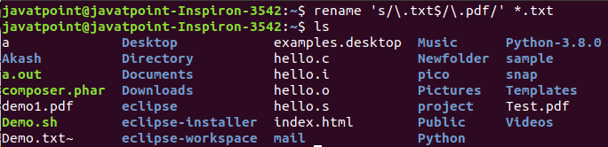
2. head command:- It is used to display the content of a file.

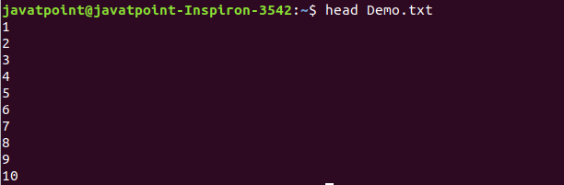

1. more command:- This command is quite similar to the cat command, as it is used to display the file content in the same way.

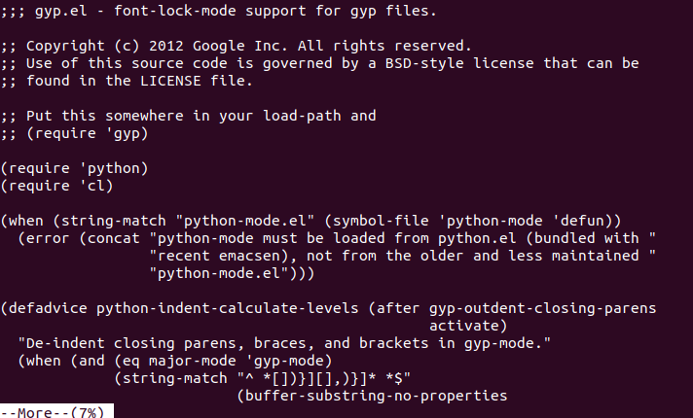

1. id command:- is used to display the user ID and group ID.

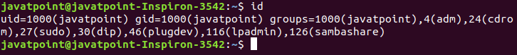

1. passwd command:- is used to create and change the password for a user.

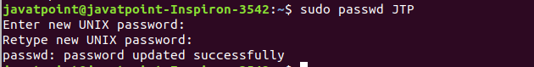

1. exit command:- This command is used to exit from the current shell.
2. clear command :- It is used to clear the terminal screen.
3. Whoami :- This command tells you about the system username.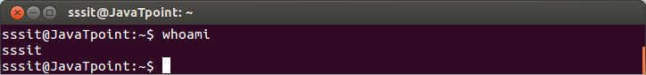
4. Who:- This command gives the info about the user logged on to the system.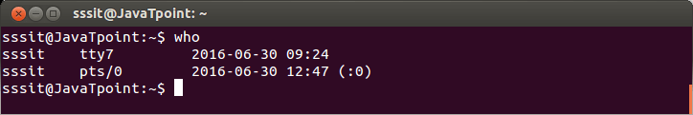
5. Man command:- This command will tells you the list of commands.
6. Cat/etc/shells:- This command tells us how many shells are in our system.